**Udacity Data Analyst Nano Degree**

**Project (Explore weather trends)**

**Introduction:** In this project, we will analyze local and global temperature data and compare the temperature trends where we live to overall global temperature trends.

**Step 1: Extracting Data**

I used the below query to extract my city’s temperature (Munich) alongside with the global temperature in 1 query:

SELECT city_data.*, city_list.country, global_data.avg_temp AS global_temp FROM city_data

JOIN city_list

ON city_data.city=city_list.city

JOIN global_data

ON city_data.year=global_data.year

WHERE city_list.city='Munich';

**Step 2: Working on the data**

I used Excel while working on the data. First, I calculated a 10-year moving average as illustrated in the online video. I calculated the 10-year average for both the city temperature “Munich temp (Avg 10 years)” and the global temperature “Global temp (Avg 10 years)”, by averaging the past 10 years for each year starting from 1759 usign AVERAGE function in Excel.

**Step 3: Visualizing data**

I draw a plot for the columns “Munich temp (Avg 10 years)” & “Global temp (Avg 10 years)”using Insert Line Chart tool in Excel placing the year on the x-axis, Munich & global temperatures on y-axis (Munich= orange line, Global= grey line).

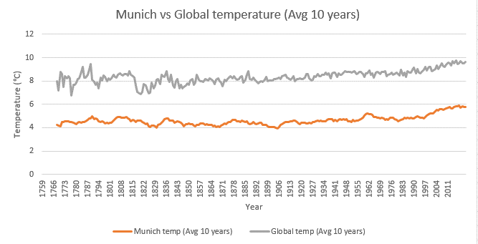

**Step 4: Observations**

**Observation 1:**

The global temperature faced a degradation in temperature from 1815 till 1836.



**Observation 2:**

Munich temperature have never exceeded the average global temperature (City is always cooler than the average global temperature).



**Observation 3:**

Munich temperature as well as global temperature have faced a continuous increase in temperature since 1997 (Global warming).



**Observation 4:**

Global temperature have faced fluctuations between years 1773 & 1794, also almost stable range between years 1829 & 1927.

Munich have sustained a stable average temperature until 1997.



**Observation 5:**

Global temperature has never exceeded 10 degrees. Munich temperature has never exceeded 6 degrees.



**Extra cities**

**Cairo**

Applying the same steps as before on Cairo city. It can be observed the following:

* Average Cairo temperature is double average global temperature and have never decreased below the average global temperature.
* 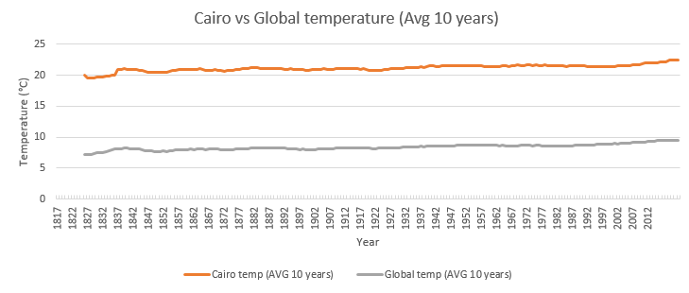Average Cairo temperate also suffered an increase in temperature since 1997 like the global temperature and Munich temperature (Observation 3).